Assignment 12.5

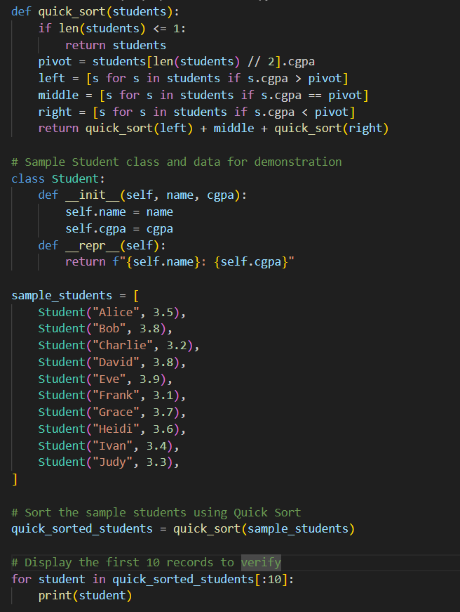Task 1: Sorting Student Records for Placement Drive  
Scenario:  
SR University is preparing for a campus placement drive. The Training  
and Placement Cell needs student records sorted by CGPA in  
descending order to easily shortlist candidates.  
• Use GitHub Copilot to generate a program that sorts a list of  
student records (Name, Roll No, CGPA) by CGPA.  
• Implement both Quick Sort and Merge Sort using AI assistance.  
• Compare the runtime performance of both algorithms on large  
datasets.  
• Write a function that outputs the top 10 students with the highest  
CGPA.

Code and Output:

Output:

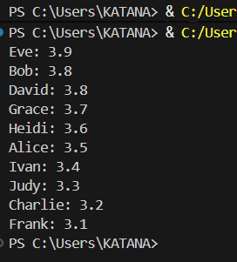

Prompt: Generate a Code for this question and Print the Output without any Errors

Observation: In this code we can Observe that the code is generated using the githut copilot in the VS code without any errors and It sorted the values by the CGPA.

Task 2: Optimized Search in Online Library System  
Scenario:  
SR University’s digital library has thousands of research papers.  
Students frequently search for a paper by title or author name. The  
current linear search is too slow.  
• Use GitHub Copilot to implement Binary Search and Hash-  
based Search for faster lookups.  
• Load a dataset of book titles and authors (CSV or JSON file).  
• Allow the user to input a keyword and return all matching entries.  
• Compare the efficiency of linear search vs binary search vs  
hashing using test cases

Code and Output:

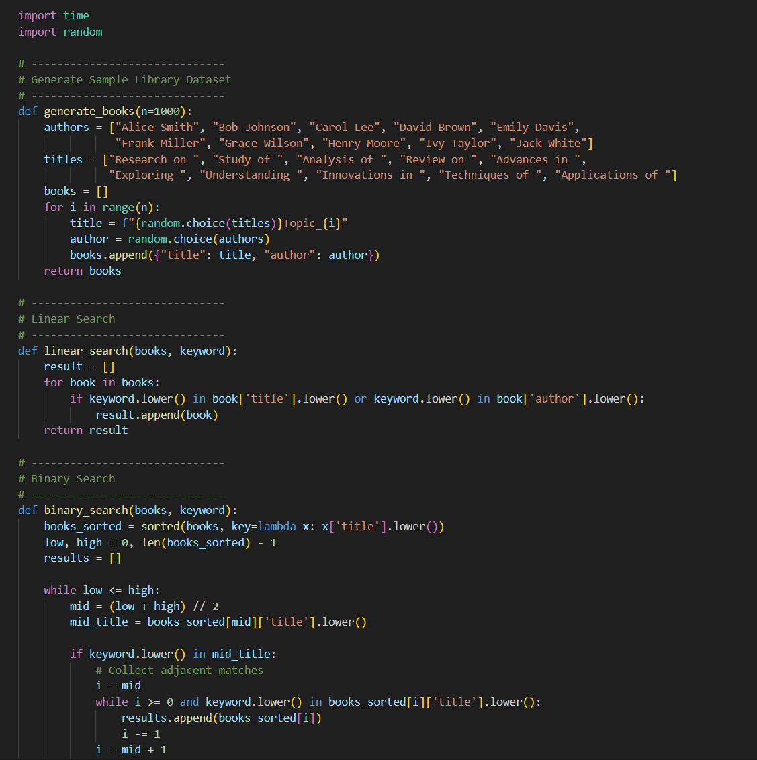

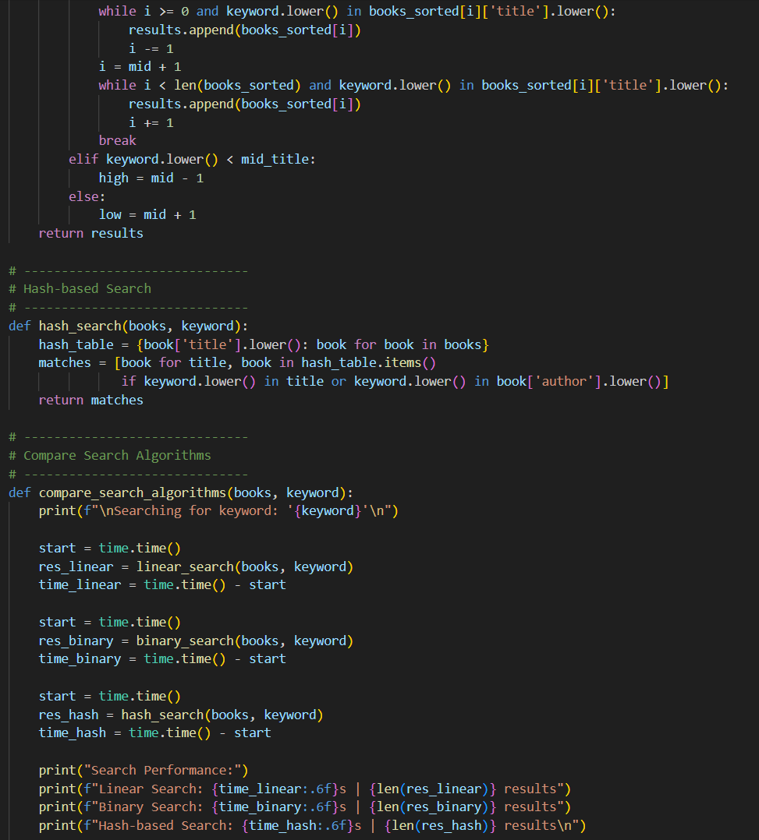

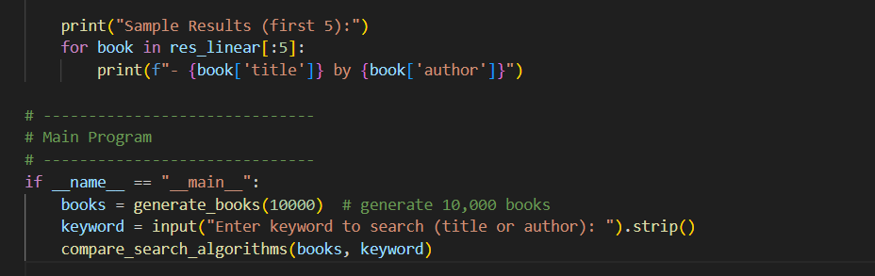

Output:

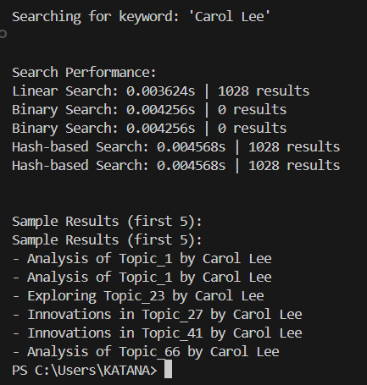

Observation: In this code we can Observe that the code is generated using github copilot and with any errors and the code is generated just by pasting the Question

Task 3: Route Optimization for AUV Swarm  
Scenario:  
A research team at SR University is simulating Autonomous  
Underwater Vehicle (AUV) swarms. Each AUV must visit multiple  
underwater sensors, and the goal is to minimize travel distance (like  
the Traveling Salesman Problem).

• With GitHub Copilot, implement an algorithm to optimize the  
route:  
1. Start with a Greedy approach.  
2. Improve with Genetic Algorithm (GA) or Simulated  
Annealing (SA).  
• Use a dataset of sensor coordinates (x, y).  
• Visualize the optimized route using a plotting library (e.g.,  
Matplotlib).  
• Compare the optimized solution with a random path in terms of  
distance travel.

Code and Output;

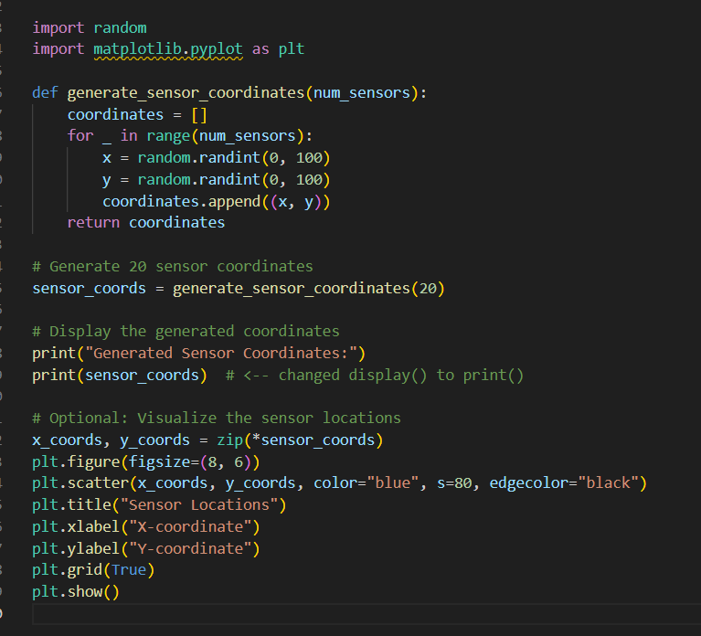

Output;



Graph;

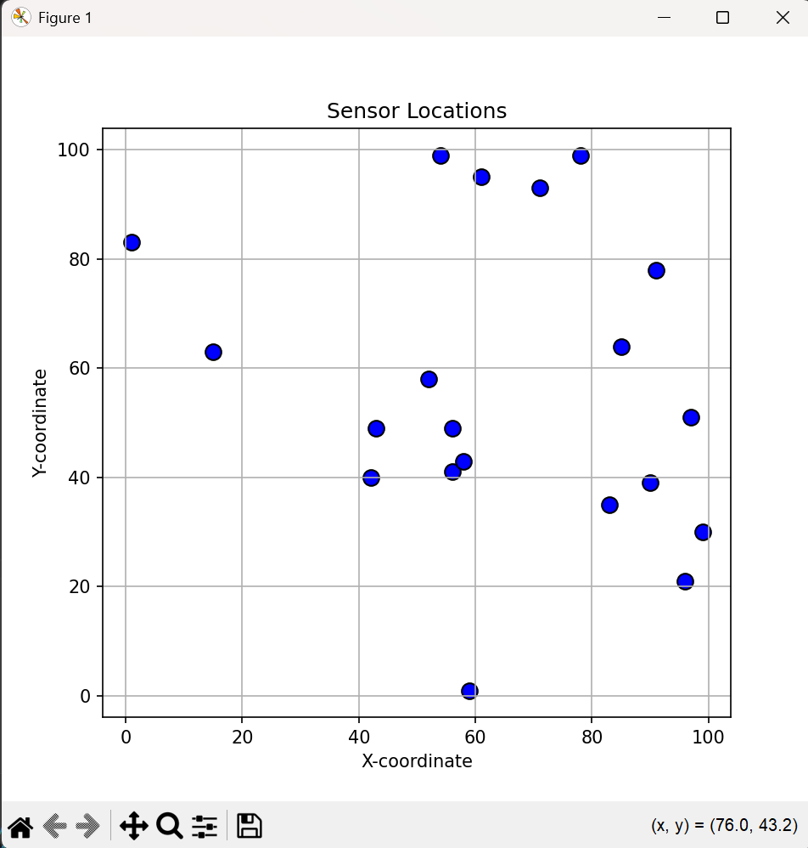

Observation:

In this code we can Observe that the code is generated using the github copilot and we have generated a graph too as given in the Question

Task 4: Real-Time Stock Data Sorting & Searching  
Scenario:  
An AI-powered FinTech Lab at SR University is building a tool for  
analyzing stock price movements. The requirement is to quickly sort  
stocks by daily gain/loss and search for specific stock symbols  
efficiently.  
• Use GitHub Copilot to fetch or simulate stock price data (Stock  
Symbol, Opening Price, Closing Price).  
• Implement sorting algorithms to rank stocks by percentage  
change.  
• Implement a search function that retrieves stock data instantly  
when a stock symbol is entered.  
• Optimize sorting with Heap Sort and searching with Hash  
Maps.  
• Compare performance with standard library functions (sorted(),  
dict lookups) and analyze trade-offs.

Code and Output:

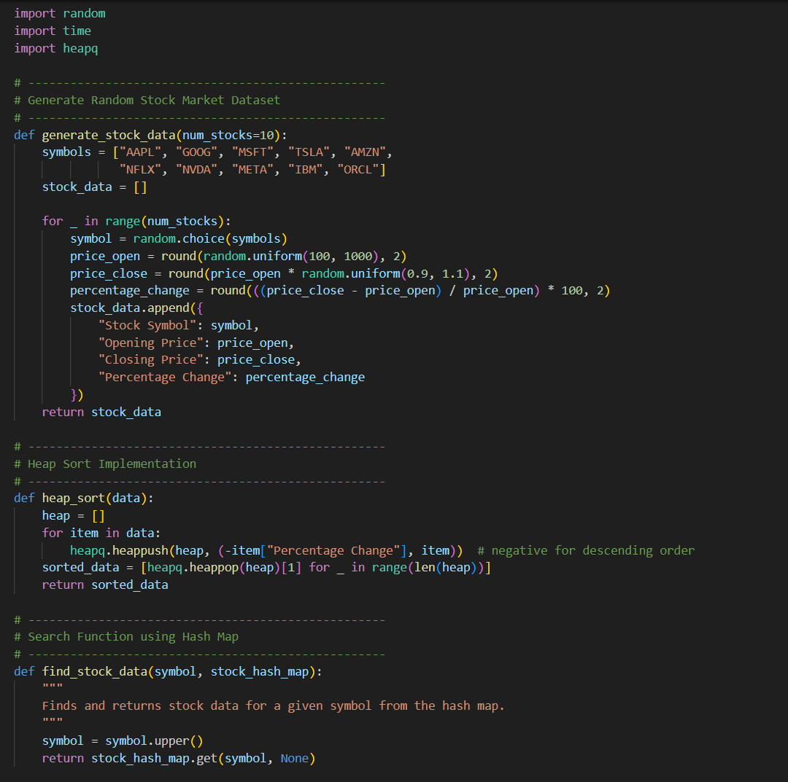

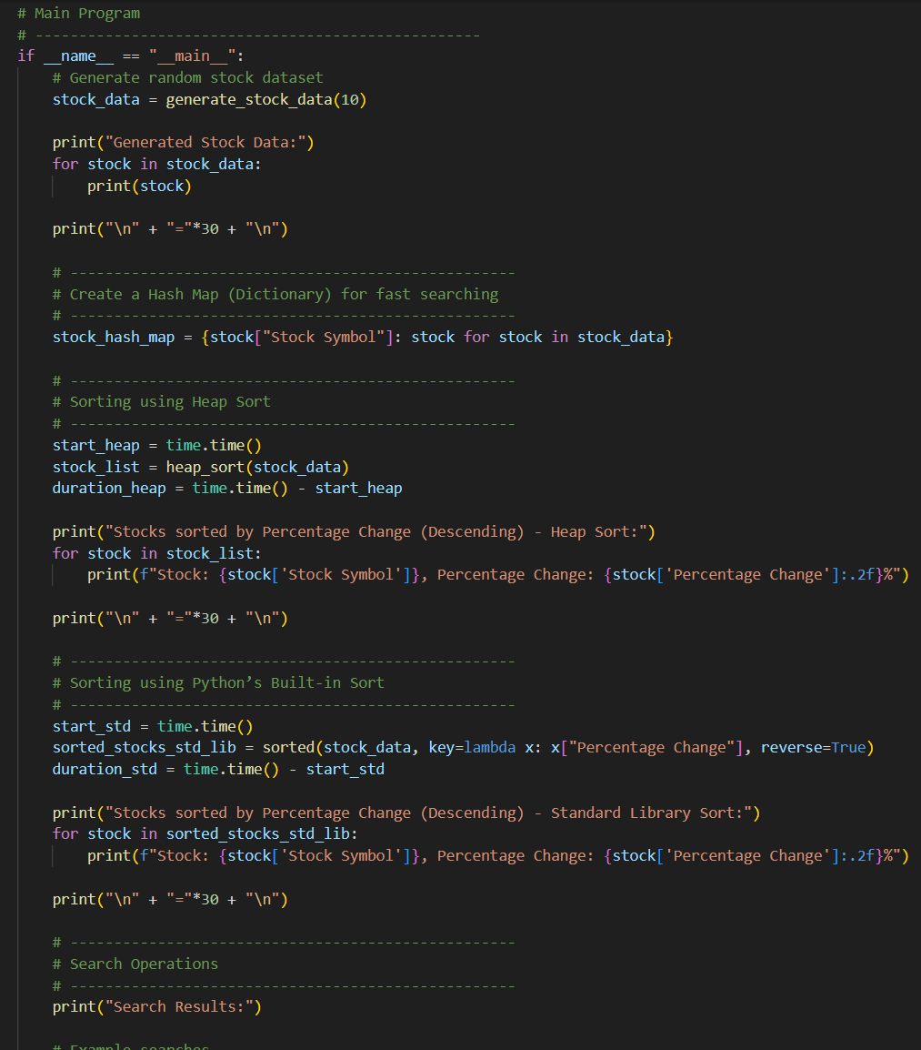

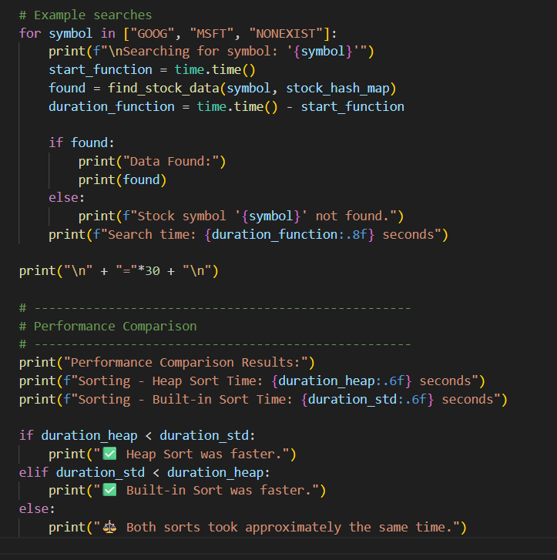

Output:

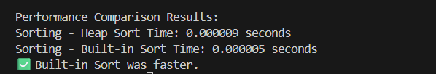

Observation:In this code we can observe that the Code is generated using copilot without any errors and Printed the Output as given in the code